**VMM Africa t/a Association of Mission Volunteers**

**World of Work (WOW) Programme – Kitale, Kenya**

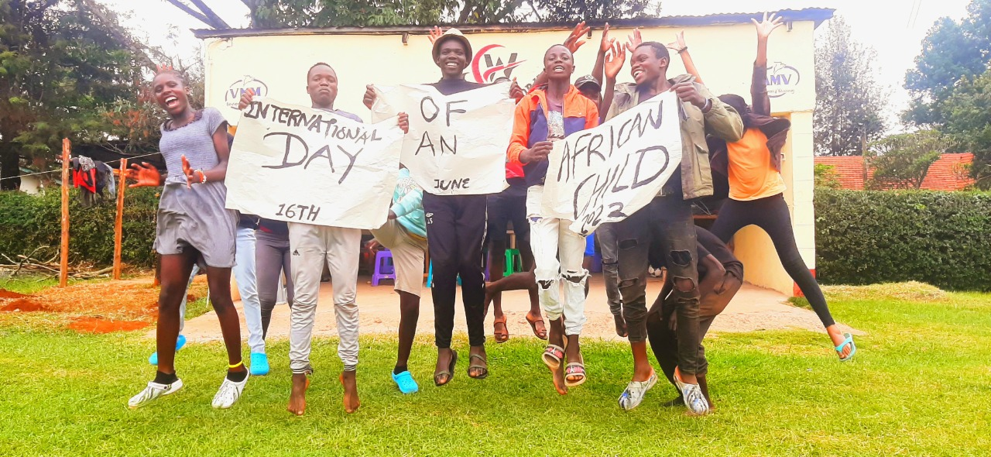

World of Work is a project of VMM Africa, trading as Association of Mission Volunteers (AMV). It is a project which piloted in Kitale commencing January 2021. It results from work carried out by VMM during 2019 and 2020 when there was various engagement with street connected youth and various stakeholders. The programme focuses primarily on participants (aged 17 -24 years old) who are homeless and living on the streets of Kitale. The initial pilot WOW 1 and the subsequent WOW 2 group just involved males. During WOW 3 girls have come to the programme and will continue to be a focus for the programme going forward.

This project has 5 objectives:

1. To enable street connected & homeless male and female youth to have access to vocational training opportunities whether formal or informal

2. To enable street connected & homeless male and female youth to have access to employment opportunities

3. To enable street connected & homeless male and female youth to have access to affordable accommodation (likely funded for up to a year)

4. To enable street connected & homeless male and female youth to have access to personal development & lifeskills training and opportunites

5. To provide ongoing and follow up support

Activities of the programme include (but not limited to):

* Craft production – including card-making, picture/ wall plaque making, beading etc
* Basic Agriculture inc management of poultry and rabbits
* Catering
* Business Skills
* Hair & Beauty training
* Plan for tailoring
* Work experience and attachments
* Introduction to computers
* Lifeskills & Personal Development incl issues of addiction, relationships, HIV&Aids (we provide counselling and testing onsite) etc
* Social, sports & environmental activities – every Friday is spent at Kitale museum where the WOW team are entrusted with landscaping, cleanups and signage at the museum.
* Home reconnection & visits
* Referrals where appropriate eg for medical treatment

The venue is Edwina Gateley House in Milimani, Kitale. This is on a 1.5 acre site and is leased. It also houses the VMM Africa office and volunteer accommodation. The WOW programme is a day service runing from Mondays to Fridays from 9.00am to 2pm daily. The group taken on for any period is in the region of 10 participants. Going forward we hope that each group will include 3-4 girls. The first phase of attending daily at Edwina Gateley House takes about 5-6 months. After that follow up and support continues as needed. By the end of the first phase the young person should be settled into a house and be in a position to begin to build on skills learnt by way of apprenticeship, supported employment or be assisted to run a small business.

Breakfast and lunch is provided – It is prepared by the young people themselves using a rota. An allowance for food is provided at the weekend. When the young person is housed basic household items are provided.

Our team has 4 people fulltime, 3 volunteers and 4 part-time people working from 1-2 days a week as the need arises. We also have a small field office in Kitale town for ease of followups with landlords, places of apprenticeships, attachments etc

Our long term plan would be to have our own coffee shop / restaurant and a barbershop & salon in Kitale so that work experience and training of a more supported nature could be provided to the youth before they may more independently join the workforce market.

